

**MONTHLY PROGRESS REPORT**

**TA-9950 REG: IND: Health Systems Strengthening Firm**

Aug 2023



# **Objective of Report**

The main objective of this monthly report is to provide an update on the significant tasks undertaken and progress made towards achieving the set objectives in the terms of reference (TOR). The report details out monthly advancement across key work areas as well. The main issues are identified with steps taken to address them. For ease of progress monitoring, all primary deliverables achieved yet are enlisted for each essential work area. Additionally, a monthly progress update on salient tasks undertaken by individual team members deployed at NHSRC within each of the five key work streams is also highlighted.

# **Scope of work**

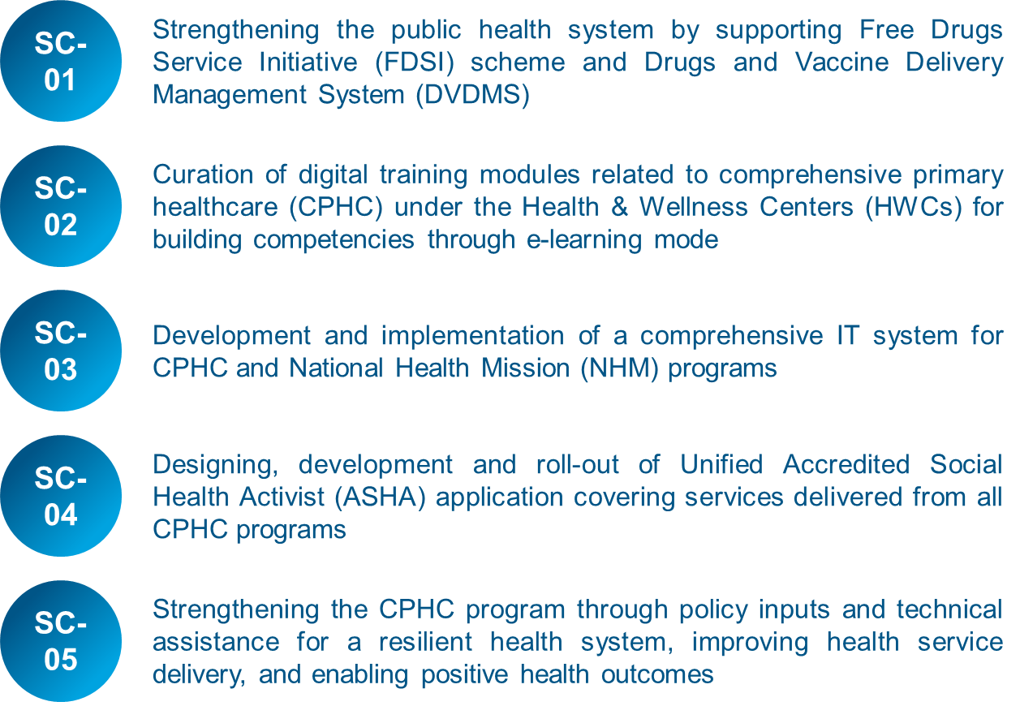The foremost objective is to support new applications’ development under National Health Mission (NHM) and extend support and maintenance towards existing portals/app platforms with integration tasks towards any initiatives under NHM at National level (including states /ministries & other Govt. Institutions). Apart from these activities, team will also support in bridging the gap between different program divisions and their IT vendors in terms of technical understanding. The scope of work is specified under the section 1.5 of the TOR.

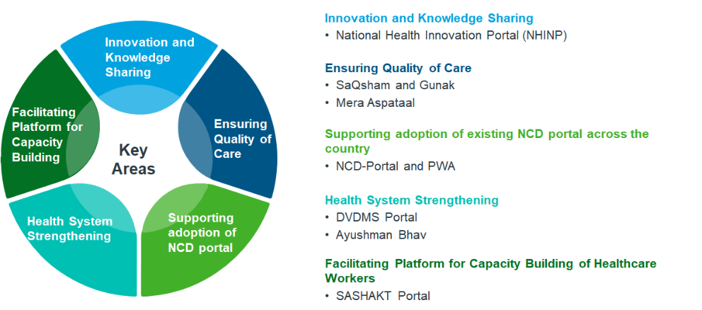Furthermore, the MoHFW has implemented several innovative programs and technology solutions across India such as SAQSHAM, Gunak, Mera Aspataal, NCD-Portal & PWA, DVDMS etc. These initiatives and solutions are important steps towards improving the quality of healthcare services and addressing some vital challenges facing the Indian healthcare sector. It is eminent that all tasks carried out by the team are aligned with the TOR's established scope of work to ensure quality delivery and efficient completion of this project. The overall scope of work can be broadly divided into the following areas for ease of co-ordination and better progress monitoring:

1. **Innovation and Knowledge** sharing
2. Ensuring **Quality of Care**
3. Supporting adoption of **Existing NCD Portal** across the country
4. **Health System Strengthening**
5. Facilitating platform for **Capacity Building of Healthcare Workers**

# **Monthly progress update**

This report provides a status update on the project’s progress from the inception i.e. 1 Aug 2023 till 31 Aug 2023. Therefore, for effective work progress monitoring, the following information is provided for each of the five major tasks:

* Key challenges and their possible solutions/recommendations
* Key tasks undertaken
* Next month plan
* Major deliverables

# **Monthly progress of overall tasks that have been undertaken by the team deployed at NHSRC across each of the five key work areas**

# **Innovation & Knowledge Sharing**

|  |  |
| --- | --- |
| **Key Particulars** | **Related Program#1: NHINP** |
| **Key tasks undertaken** | * Regular meetings with HCT and KMD divisions for freezing the scope * Incorporate the changes in the system and include new modules * Development of application for new/pending functionalities * Analysis and impact on the business and process flow as per the updated requirement * User Acceptance Testing of the software by both the program divisions * Completion of 1st level of security audit |
| **Key challenges** | * Finalization of scope for 1st release * Finalization of design |
| **Identifying possible solutions / recommendations** | * Database design needs to be changed to incorporate the changes in the logic of the form * Rework based on the change in design |
| **Identifying next steps** | * Finalization of new UI/UX design of frontend portal based on the feedback from HCT and KMD teams * Hosting of the website on the server * Updates in the portal * GIGW compliance and security audit * Bug fixing based on the findings from the UAT and compliance report |

**Key deliverables of the project:** 1st report of security audit

* + 1. **Ensuring Quality of Care**

For SaQsham, meeting was held with QPS and CDAC team to get the data for Aspirational Block program. Support was provided to QPS division in resolving technical issues with CDAC team for multiple queries.

# **Supporting adoption of existing NCD portal across the country**

|  |  |
| --- | --- |
| **Key Particulars** | **Related Program#1 NCD** |
| **Key tasks undertaken** | **NCD State Level Work**   * Data Migration for all the 33 districts of Telangana has been completed. Data verification is in progress * For NCD West Bengal deployment State Data Center (SDC) and hardware setup has been completed. Sharing of the Master data and knowledge transfer for its understanding has been provided to the State team * Updated village mapping excel sheets shared by Madhya Pradesh State team has been verified and village transfer task for 21 districts has been started * Coordination with Rajasthan team for understanding requirement of integration of Asha Soft (payment app for ASHA) with NCD * Coordination with Kerala State team regarding hybrid integration with NCD portal * Coordination with Meghalaya State team to resolve their queries on line-listing data NIN Id mapping   **NCD Integration Tasks**   * Coordination follow up with NITI Aayog team on successful consumption of API shared for HWC & NCD * Provided technical support to Ladakh team for LG Dashboard * Discussion held with Uttar Pradesh team for e-Kavach integration with NCD wherein State has requested to use e-Kavach and only share cumulative data with NCD portal through API * Understood NCD data entry in e-Shushrut for integration purpose and checking on the possible indicators for integration at PHC level   **Other Tasks for NCD**   * Coordinating with NIC regarding NCD-API publication in NAPIX. Working on the Proof of Concept for NAPIX * Coordination and follow up with Maharashtra team for data migration of urban facilities from Simple App to NCD * Provided technical support to CHI regarding RFP for cloud infra for NCD * Provide Knowledge Transfer session to State Nodal Officers for procuring Virtual numbers & WhatsApp business account for integration of Toll-Free and WhatsApp with NCD * Working on the one view dashboard for GOI NCD and Non GOI NCD States * Coordinated with NIC & MoHFW for providing NCD Parichay SSO key |
| **Key challenges** | * Delay from West Bengal State team to complete set up * Demo pending for NAPIX from NIC team * The hybrid integration as requested by Kerala State team has never been done by the NCD team |
| **Identifying possible solutions / recommendations** | * To maintain regular follow up with the West Bengal State team * To maintain regular follow up with NIC team * To do feasibility analysis of the Kerala integration request with internal stakeholders |
| **Identifying next steps** | * Village transfer request pan-India will be managed by the team * Landing page auto-update, development, testing and deployment * Integration of WhatsApp and Toll -Free Number * GOI NCD & Non-GOI NCD single dashboard |

**Key deliverables for project:**

1. Migration of data for all 33 districts of Telangana on NCD Portal completed

# **Health System Strengthening**

|  |  |  |
| --- | --- | --- |
| **Key Particulars** | **Related Program#1: DVDMS Portal** | **Related Program#2: Ayushman Bhavah Portal** |
| **Key tasks undertaken** | * Finalized the Business Requirement Document (BRD) document for the integration of DVDMS with NCD * Coordination with CDAC & MoHFW team for sharing the manual for onboarding of NCD on Central Dashboard * Coordination with Dell, Tata Trust and MoHFW for providing the VPN access and NCD pre-staging environment access to vendor for initiating the development process and technical documentation for NCD-DVDMS integration | * Meeting with steering committee on possible home page design and indicators * Coordination with different program teams like NCD, Sickle Cell, TB, PMJAY, ABDM for sharing data according to respective indicators * Coordination with vendor for procurement of server * Coordination with NIC for SSL and domain name * Coordination with NHSRC IT Section for procuring Infra * Set-up infra for the portal * Development of Portal with Database design, portal design and LGD mapping * Demo of the portal to JS Policy & ED- NHSRC * Updating the BRD based on the inputs of the steering committee |
| **Key challenges** | * Delay in providing the VPN access and NCD pre-staging environment access | * Delay in data sharing from different program teams for the proposed indicators * Lack of clarity on unit level (village/panchayat) * Very short timeline for development * Frequent change in requirements |
| **Identifying possible solutions / recommendations** | * Follow-up with Tata Trust, Dell & MoHFW team to expedite the process of granting the VPN access and NCD pre-staging environment access to the vendor | * Formation of dedicated WhatsApp group with all the relevant stakeholders from program divisions, CPHC division & steering committee for timely coordination |
| **Identifying next steps** | * Integration development and technical documentation | * Launch of the portal * Finalization and approval on BRD (Business requirement) document * Continuous monitoring, maintenance and support to the portal after launch |

**Key deliverables:**

1. Screenshots of Ayushman Bhava Portal **(Annexure-1)**

# **Facilitating Platform for Capacity Building of Healthcare Workers**

|  |  |
| --- | --- |
| **Key Particulars** | **Related Program#1 Sashakt Portal** |
| **Key tasks undertaken** | * Analysis of issues coming from states and aligning the task to team, based on the priority * Development of new modules as per the requirements of the program division * Analysis of the database architecture for proper understanding of the tables * Involved in SSO integration process for ease of usability to the users |
| **Key challenges** | * SSO integration with Parichay at district level |
| **Identifying possible solutions / recommendations** | NA |
| **Identifying next steps** | * Enabling new features * Complete support and maintenance |

**Key deliverables for project:**

* Proposed workflow for Sashakt Integration (**Annexure-2**)

# **Monthly progress update of the key task undertaken by the team members deployed at NHSRC across each of the five key works areas**

|  |  |  |  |  |  |  |
| --- | --- | --- | --- | --- | --- | --- |
| **S.No.** | **Key Personnel** | **Innovation & Knowledge Sharing** | **Ensuring Quality of Care** | **Supporting adoption of existing NCD portal** | **Health System Strengthening (HSS)** | **Capacity Building of Health Care Workers** |
| 1. | Senior Consultant- Public Health & IT (Ashutosh Sharma) |  |  |  |  |  |
| 2. | Consultant-Product Management (Shashi Prabhakar) |  |  |  |  |  |
| 3. | Consultant- DVDMS/FDSI (Himanshu Singhal) |  |  |  |  |  |
| 4. | Solution Architect (Soumyajit Pati) |  |  |  |  |  |
| 5. | DevOps Expert (Sushil Kumar Tiwari) |  |  |  |  |  |
| 6. | Software Developer (Nadeem Ahamed) | * Work on product form second step not submitting issue in NHINP * Work on security audit point fixes in NHINP Portal. |  |  | * Work on create cron to get sckile cell data API * Work on menipulate data to store in database which is getting from sckile cell data * Work on abha Indicators API to fetch data for ayuman bhav portal * Work on abha indicators save API response data for ayushman bhav portal * Work on NCD Indicators API to fetch data for ayuman bhav portal * Work on NCD indicators save API response data for ayushman bhav portal * Work on PMJY Indicators API to fetch data for ayuman bhav portal * Work on PMJY indicators save API response data for ayushman bhav portal * Work on create API request logs and manage count of total records, partial inserted, missing count, etc. * Work on upload images from report form and save in databse acordingly CHC Mela portal * Work on display event image list in CHC Mela portal * Work on edit flow of event image in CHC Mela * Work on Update event image status flow by state level user in CHC Mela portal * Work on add filter on event image listing page on state level user portal in CHC Mela portal. * Work on event report image compression in CHC Mela portal * Work on display total event count with image upload in progress report in CHC Mela portal * Work on sicklecell api exculde entry flow in ayushman bhav * Work on remove and update event image on edit event report/complete in CHC Mela |  |
| 7. | Software Developer (Brij Kishore Singh) |  |  |  |  |  |
| 8. | UI Developer (Vikash Kumar) |  |  |  |  |  |
| 9. | UX Designer (Dinesh Dogra) |  |  |  |  |  |
| 10. | Senior Consultant- Engineering (Saurabh Juneja) |  |  |  |  |  |
| 11. | Consultant- Engineering (Praveen Sharma) |  |  |  |  |  |

**Annexure 1**

**Screenshots of Ayushman Bhava Portal**

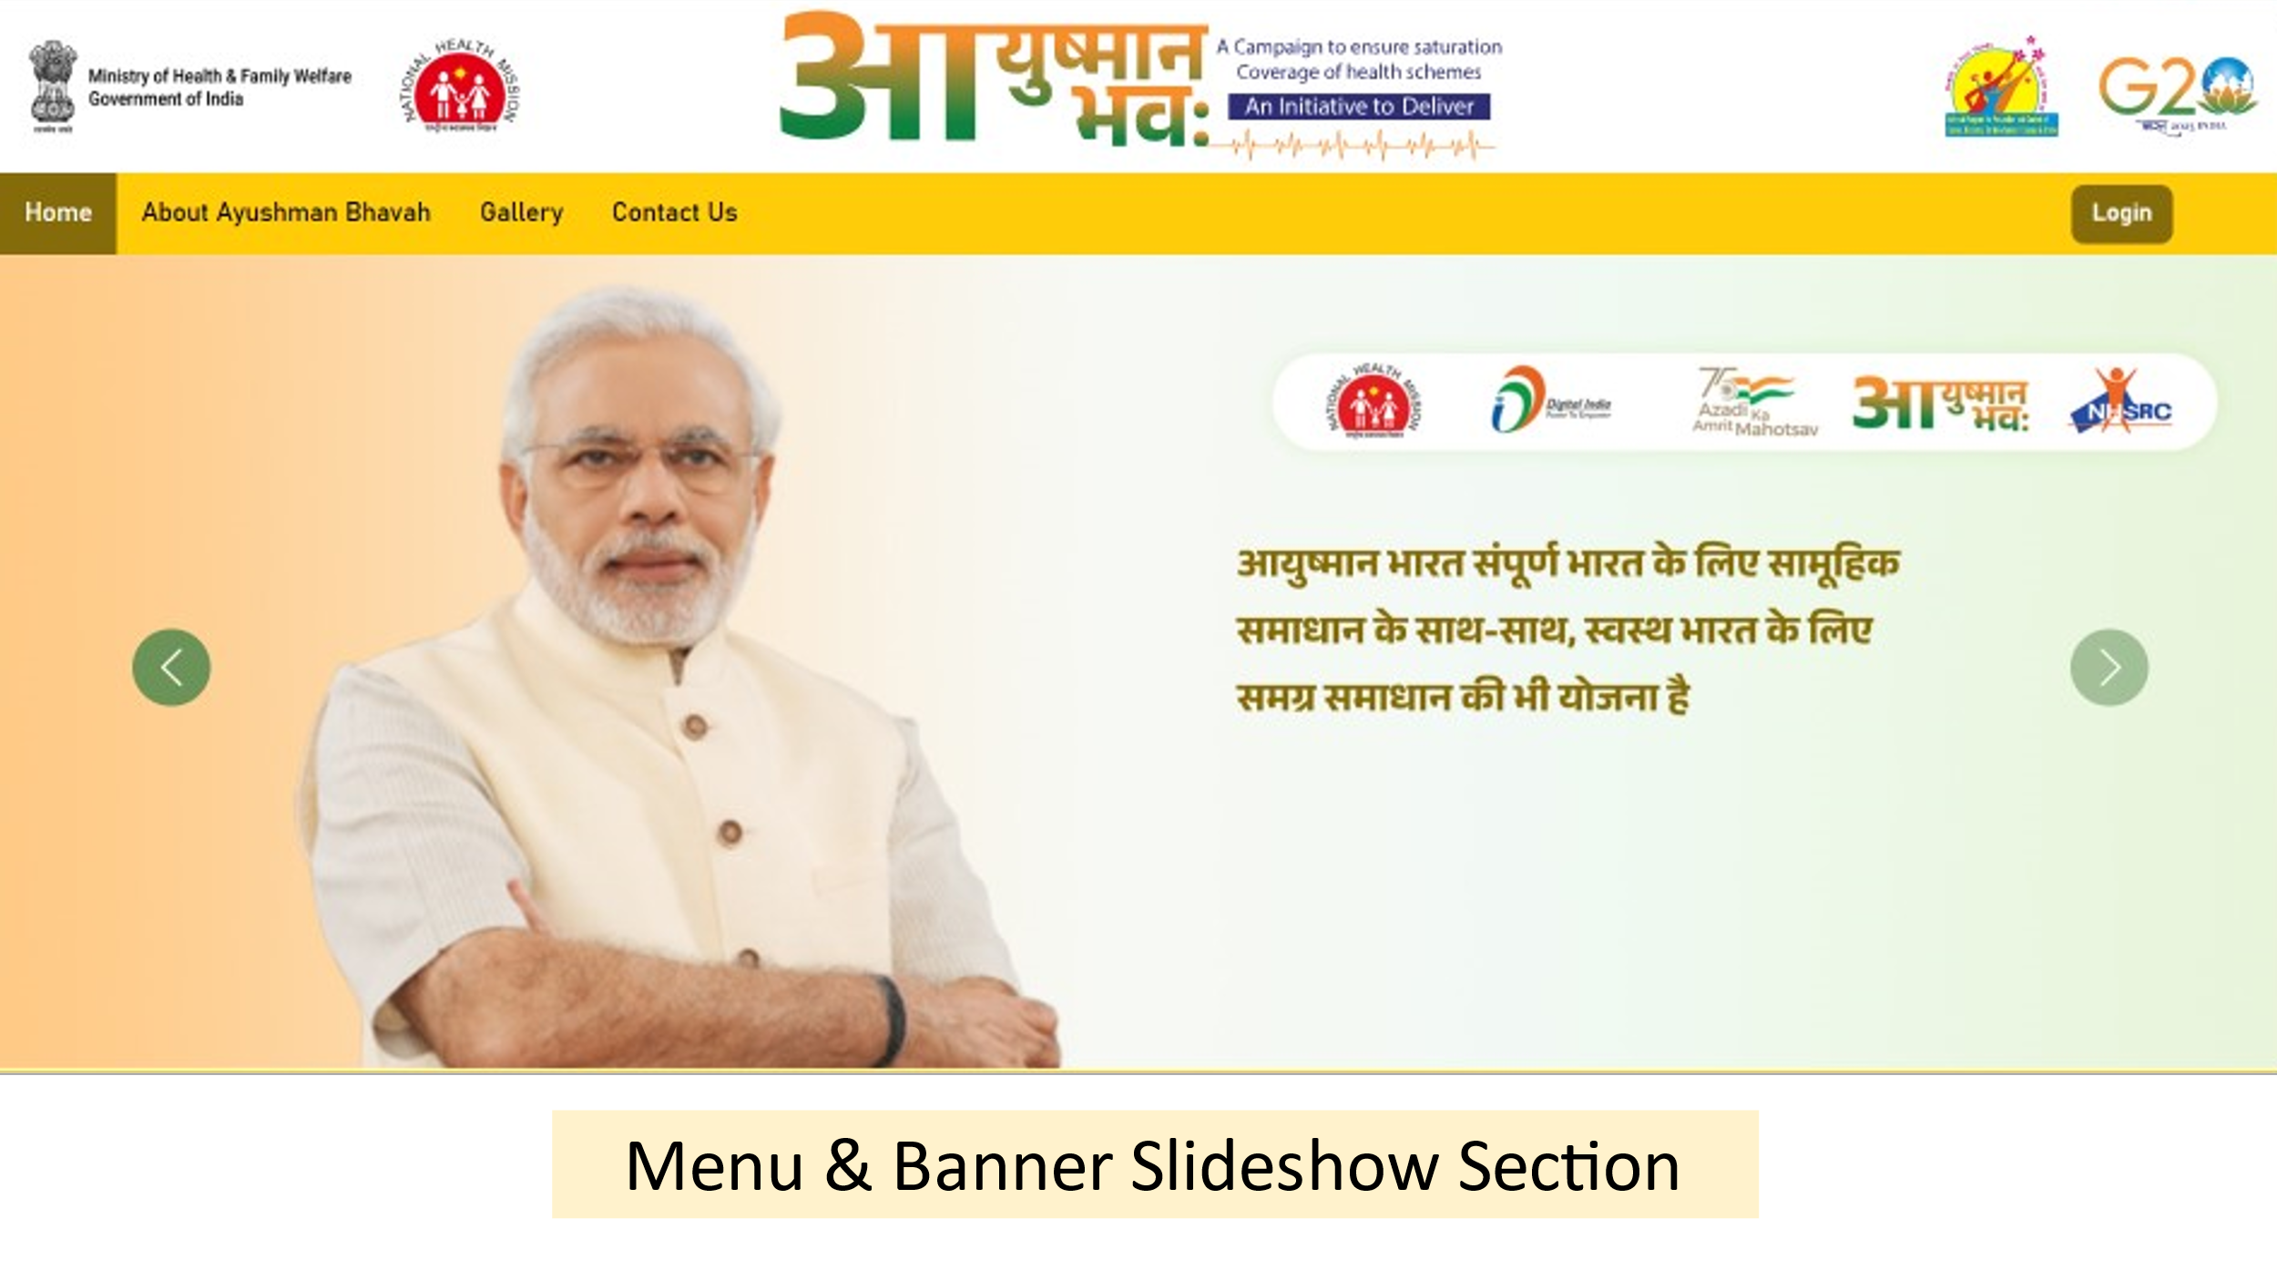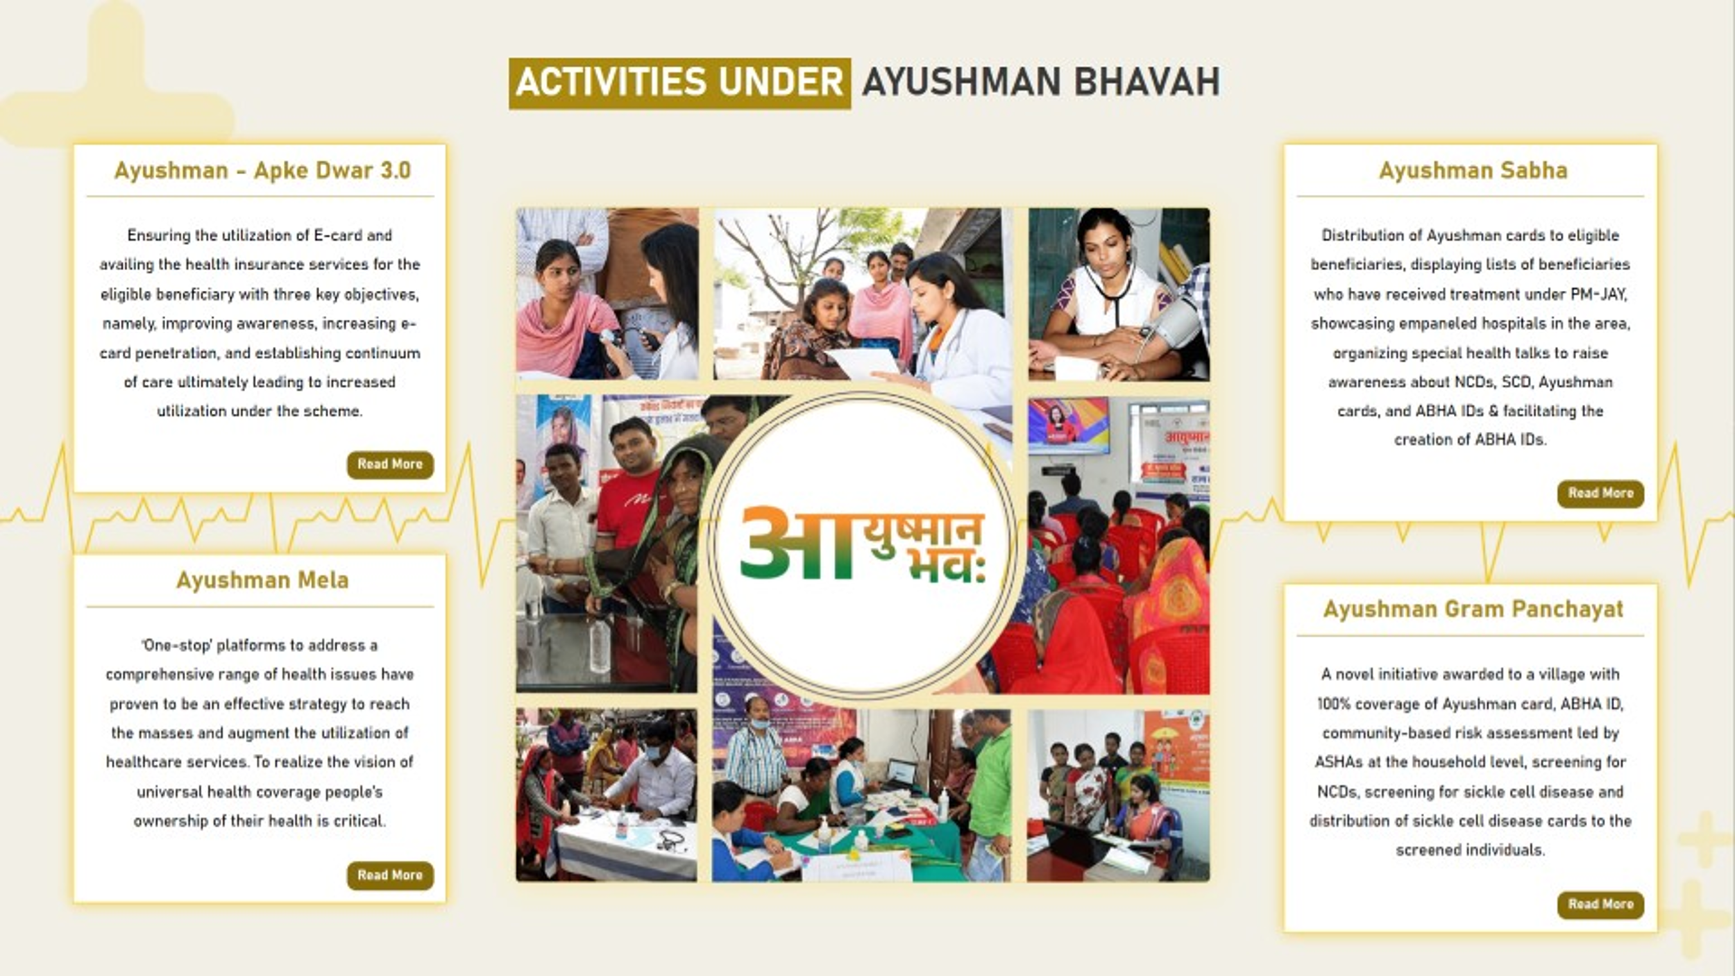

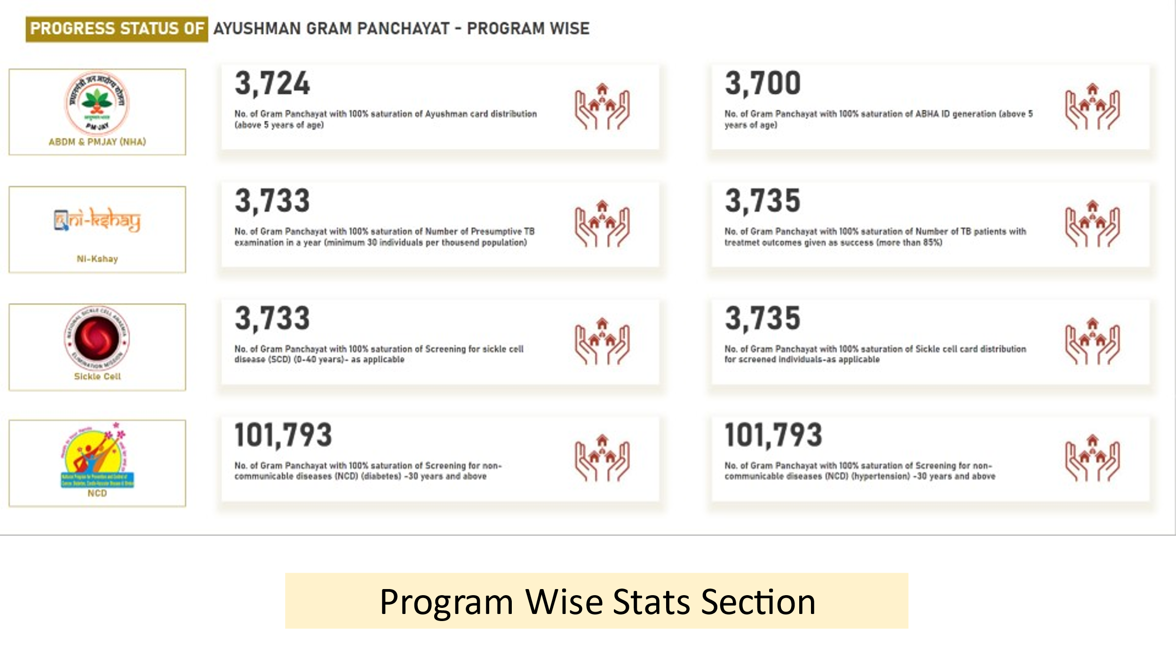

**Annexure 2**

Proposed integration of SASHAKT portal with other portals

Portal Brief

Ayushman Bharat Health and wellness centers are expected to deliver an expanded range of services both at SHCs as well as PHCs, closer to the communities. The level of complexity of care of services delivered at the PHC would be higher than at the sub health center level as per the standard defined pathways. Operational Guidelines of all expanded service packages (Eye, ENT, Oral, MNS, Emergency, EPC) have been launched on 14th April 2021. States are required to roll-out all the 12 service packages under comprehensive primary healthcare at operationalized AB-HWCs. Knowledge and skill building are deemed essential to ensure quality of services provided at AB-HWCs. Annual grants have been allocated to the states for multiskilling and continuous capacity building of health care team. Technology support will enable and ensure better planning and execution of trainings.

In order to support states in implementation and monitoring of trainings, National Health System and Resource Centre (NHSRC) has developed Training Monitoring web portal known as SASHAKT – Systematic Assessment of Health care providers Knowledge and Training. This portal is designated to provide real-time update on the progression of trainings. The specific purpose of training monitoring software is as follows:

1. Support the states in planning trainings for health care functionaries
2. Monitor the quality of trainings
3. Determine the real-time status of training of healthcare functionaries
4. Timely documentation and reporting on the status of training

Major Functionalities in the Portal

1. Three Steps Registration - Basic Details, ABHA Verification, Success for M.O, CHO, Staff Nurses, MPW, ASHA, JAS committee members and Trainers
2. User Login as per user roles
3. User management in admin for different role (Admin, State User, District User, Demo User, Participants, Supervisor)
4. Dashboards at Admin level users with following stats -
   1. Training scheduled
   2. Trainings Completed
   3. Trainings Pending
   4. Upcoming Trainings
5. State and district filter in dashboard data.
6. Training Plan module according to Service, Package, Trainers etc.
7. Participants management with different cadres (M.O, CHO, Staff Nurses, MPW, ASHA)
8. Trainer management Module with different Package (Oral Care, Eye Care etc.) for different Cadres (CHO, MO etc.) and Level of trainers (National, State, District and Block)
9. Certificate management module for dynamic creation of certificate with individual details for completed training
10. Setting Module for generic configuration
11. Training Video Section (Add YouTube link, Upload video or iframe)
12. Reports Section with following type of reports

* Cumulative Report
* State Ranking Report
* Training Status Report
* Training District Status Report
* Package Wise Report
* Training wise report
* Participant wise report

Overall Gaps & missing functionalities

After conducting a thorough analysis of functionalities available in the Portal, it was found that there were many gaps and functionalities missing from SASHAKT portal that makes the portal non-comprehensive in terms of complete Learning Management System. Complete list of such instances has been curated and listed for reference –

1. UI/UX is not user friendly and lacks the design philosophy
2. Currently all the training are conducted offline, there is no mechanism to conduct trainings online through Webex/google meet/zoom etc.
3. Since the trainings are conducted offline, the attendance of the participants needs to be marked manually in portal through admin panel or excel import
4. Completion certificates are generated from Admin panel only after marking the attendance manually
5. There is no provision for Single Sign On (SSO) in the portal with Parichay portal for enabling auto login of Govt officials in SASHAKT
   1. The Parichay application enables user to access the various government applications through a seamless 2-step verification process
   2. Parichay Authenticator offers both token verification and tap verification for the authentication and authorization of the users
6. The portal is yet to have integration with National Institute of Open Schooling (NIOS). NIOS has training and certification for ASHA for the training tailored to the work tasks to ASHA. Since SASHAKT also has training modules for ASHA, the NIOS data specific to ASHA should reflect in SASHAKT also against the same ASHA
7. The portal is not currently integrated with SAKSHAM. Since there are many training courses on SAKSHAM which are not present in SASHAKT for many of the cadres, there is a need of integration.
   1. Healthcare workers and administrators can utilize SAKSHAM to acquire globally relevant knowledge at their own comfort and pace from anywhere across the country without consuming the work hours. It is envisioned to be utilized for all blended learning programs in the future
   2. Work is in progress for integration.

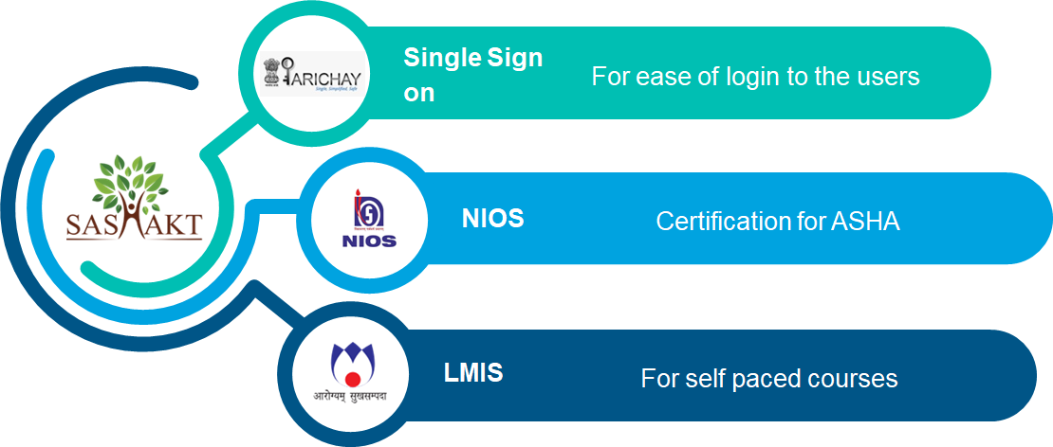

1. Integration with NIOS
   1. Various meeting have been held with NIOS technical team to understand the challenges of integration.
      1. Provision for ABHA creation to be provided on NIOS portal for new ASHA’s registering on the portal. For this purpose, NHA M1 integration is needed.
   2. Team has proposed the solutions to the challenges as follows –
      1. The scope of the integration will be confined to provide provision to ASHA to download the certificate of completion from Sashakt portal once she completes training on the NIOS portal
      2. NIOS will provide the certificate template to Sashakt team, which will be implemented in the Sashakt portal.
      3. NIOS will upload the certificate in the Digi Locker application, from DigiLocker Sashakt will have the provision to download the certificate from DigiLocker through ASHA’s login. For this integration of Sashakt portal with DigiLocker will be required.
      4. Team will facilitate and help NIOS for the same.
   3. Modes of integration needs to be finalized in agreement between both portals
2. Integration with SAKSHAM
   1. Detailed document on Possible workflows for the integration has been compiled and shared in upcoming section of this document
   2. Meetings with both programs are underway to reach agreement on method of integration
   3. Live online trainings module is in progress of development in SAKSHAM, once the integration is carried out successfully, the online trainings will start in SASHAKT

Proposed Solutions for integration of Sashakt with Saksham

As per the recommendation from MoHFW, it has been suggested to integrate Sashakt with Saksham (LMIS) portal of NIHFW. The integration is feasible in different ways, which has been described below using 2 different flow charts.

1st flow chart is as suggested per the discussion between Saksham team, NHSRC IT division and NHSRC CPHC division.

Proposed workflow

**Steps of the process are**

1. User will register himself /herself in the "Sashakt portal"
2. In the “Sashakt portal”, the user will find the relevant course in the course section
3. Once the user clicks on a particular course, the user will be redirected to the “LMIS portal” with auto-login
4. User details will be shared with  the “LMIS portal” through the API
5. In the “LMIS portal” user can see his/her relevant course/assessment only
6. On completion of the course/assessment, the user will be redirected to the “Sashakt portal”
7. User activity details will be shared with the “Sashakt portal” through the API
8. Users can download the certificate from the “Sashakt portal”

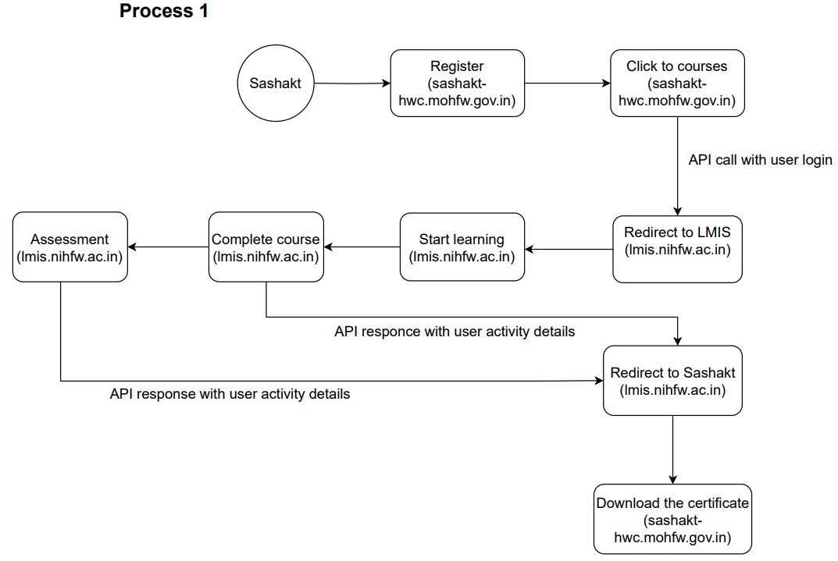

Figure 1: Sashakt integration with LMIS (Saksham): Process 1

**Note:** Three API needs to be created for this process flow are as follows:

1. Send the registered user details from the “Sashakt portal” to “LMIS portal”
2. Course activity in the “LMIS portal” needs to be sent to the “Sashakt portal”
3. Assessment activity in the “LMIS portal” needs to be sent to the “Sashakt portal”

The details of the API and stakeholders involved is shown in the table:

|  |  |  |  |
| --- | --- | --- | --- |
| Sr. No. | Task | Stakeholder | Process |
| 1 | Creating REST API for Users login credentials | Sashakt Team | Process 1 |
| 2 | Consume REST API for Users login credentials | LMIS Team | Process 1 |
| 3 | Creating REST API for Users activity details | LMIS Team | Process 1 |
| 4 | Consume REST API for Users activity details | Sashakt Team | Process 1 |
| 5 | Upload course / Assessment | Sashakt Team | Process 1 |
| 6 | Relevant course / assessment mapping | LMIS Team | Process 1 |

Table 1: Task for API creation and consumption for 1st Process

2nd flow chart is prepared with an objective to complete the integration within a short timeline

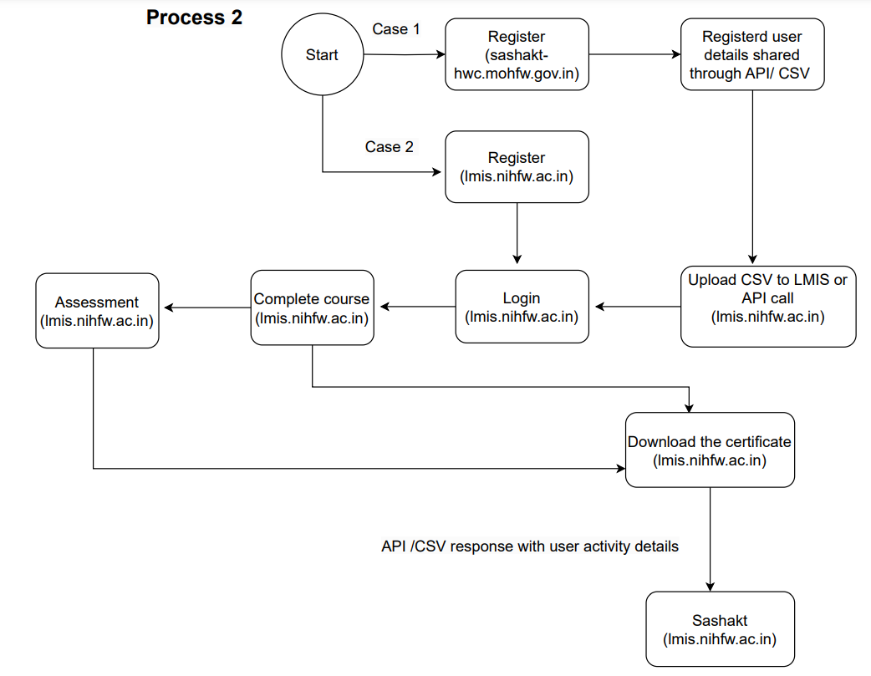Proposed workflow

Figure : Sashakt integration with LMIS (Saksham) Process 2

**Steps of the process are**

**Case 1**

1. User will register himself/herself in the "Sashakt portal"
2. Download registered users CSV from the “Sashakt portal” and upload it to the “LMIS portal” or this can also be shared through API
3. Login through the “LMIS portal”
4. In the “Sashakt portal”, the user will find the relevant course in the course section
5. Users can download the certificate from the “LMIS portal” after completing the course/ assessment
6. User activity details will be shared with the “Sashakt portal” through the API

**Note:** *Two***-***Three API needs to be created for this process flow*

1. Send the registered user details from the “Sashakt portal” to “LMIS portal” (optional)
2. Course activity in the “LMIS portal” needs to send to the “Sashakt portal”
3. Assessment activity in the “LMIS portal” needs to send to the “Sashakt portal”

**Case 2**

1. User will register himself/herself in the "LMIS portal"
2. Login through the “LMIS portal”
3. In the “LMIS portal”, the user will find the relevant course in the course section
4. Users can download the certificate from the “LMIS portal” after completing the course/ assessment
5. User activity details will be shared with the “Sashakt portal” through the API

**Note:** *At the time of registration, user needs to select/input some unique identifier*

**High level task matrix:**

The details of the API and stakeholders involved is shown in the table:

|  |  |  |  |
| --- | --- | --- | --- |
| Sr. No. | Task | Stakeholder | Process |
| 1 | Creating REST API for Users login credentials | Sashakt Team | Process 2-Case1 |
| 2 | Consume REST API for Users login credentials | LMIS Team | Process 2-Case1 |
| 3 | Creating REST API for Users activity details | LMIS Team | Process 2 |
| 4 | Consume REST API for Users activity details | Sashakt Team | Process 2 |
| 5 | Creating registered user CSV | Sashakt Team | Process 2-Case1 |
| 6 | Provision for uploading registered user CSV | LMIS Team | Process 2-Case1 |
| 7 | Upload course / Assessment | Sashakt Team | Process 2 |
| 8 | Relevant course / assessment mapping | LMIS Team | Process 2 |

Table 2: Task for API creation and consumption for 2nd Process

Recommendation:

The 1st process is the recommended method of integration and is the most feasible method and the Case 2 of Process 2 is the easiest method of integration and will be completed in the shortest timeframe.